Grades 5-8 Supply List
Please label the following items with student’s name:
- 2 bottles of white glue
- 8 glue sticks
- 1 box of 24 crayons and/or colored pencils
- 4 big pink erasers
- 1 ruler with centimeters and inches
- 1 protractor and 1 compass
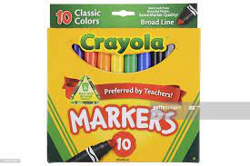
- 1 package of 3” x 3” sticky notes
- 1 package of assorted highlighters
- 2 boxes of washable classic colors broad markers
- 1 package of colored Sharpies, 1 fine-point black Sharpie
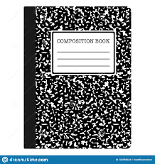
- 2 small marker boxes
- 2 pairs of scissors
- 2 college-ruled composition notebooks (any color)
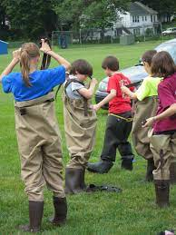
- 1 watercolor paints & craft shirt (old oversized shirt)
- waders (Academy Sports or Amazon about $28-$65)
- rain boots (if not attached to waders) the taller the better
- rain coat
- headphones or earbuds
- 1” 3-ring binder
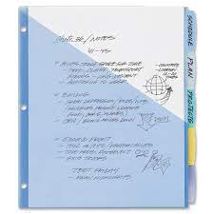
- zipper pouch for 3-ring binder
- 8 insertable plastic/vinyl pocket dividers for 3-ring binder (asst. colors)
- 1 red 2-pocket plastic folder
- 1 pocket folder of your choice (Christian appropriate designs)
- 1 clipboard
- lunch box
- spill-proof water bottle
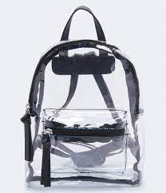
- folding camping chair
- 2 backpacks: 1 regular backpack, 1 clear for Forest School (Eastport $20 or less)
- old oversized shirt (for craft smock)
- extra change of clothing
- 8th grade only-scientific calculator

General Items that don’t have to be labeled:
- 2 rolls of paper towels
- 1 package of broad dry erase markers (multicolor)
- 3 packages of college ruled loose leaf paper
- 20-30 #2 pencils-plain yellow & good quality (i.e. Ticonderoga, etc.) or mechanical pencils
- 2 reams of white copy paper (400-500 sheets each)
- 5-15 “store” items per family that students would be buying with reward money
- 1 canister of sanitary wipes to clean off their desks

